Computer Programming
April 20 - 24

What you will need:
Computer/device
Internet
School e-mail/TEAMS/CodeHS

What you will do:

M 4/20 | T 4/21 | W 4/22 | Th 4/23 | F 4/24
Respond to your classmates POSTS from Friday  Continue Your First Karel Program (work on this for at least 15 minutes) | Continue Your First Karel Program (15 min) | Post on Discussion Board (see Topic Below)  Continue Your First Karel Program (15 min) | Continue Your First Karel Program (15 min) | Post on Discussion Board when you are done with Unit 1: Programming with Karel. If you are not done, tell us where you are.
Use the boxes below to CHECK when above task is completed (optional):

What you will learn:
Computer Programming with CodeHS

How you will complete your work:
Unit 1: Programming with Karel

Click the “Plus” sign to View Lessons.
Click PLUS sign to expand
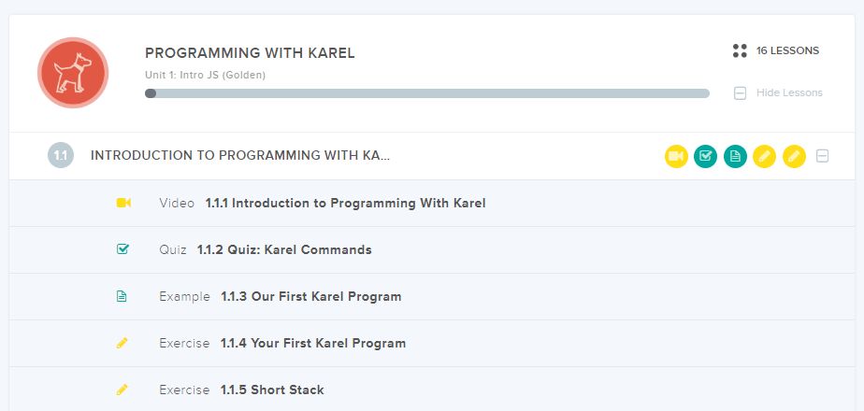

Make a REPLY and POST in Computer Programming TEAM:
REPLY
- Your classmates should have made a post on Friday about using CodeHS (see Computer Programming Apr 13-17). Reply to at least one classmate. Give helpful advice based on your experience with CodeHS and the first program.

POST
- Topic: Rank your classes in order of most important during Remote Learning, and Least Important. Next to each class, type how much time a day or week you spend on each. (no hard feelings if Computer Programming is last, I get it!)
- Reply to at least ONE classmate with conversation about the topic.

Select GENERAL on the left hand side to get back to our classroom.

“See” you next week!

